## PROGRAM DEFINITION

|  |
| --- |
|  |
| * Program untuk menambahkan SLA Category dan SLA Call Type |

## RELATED TABLES

|  |  |
| --- | --- |
|  | **Access** |
| * PMM_SLA_CATEGORY * PMM_SLA_CALL_TYPE | * RW * RW |

## ROLES

|  |  |
| --- | --- |
|  | **Test** |
| * User yg mempunyai akses ke program |  |

## INITIAL PROCESS

|  |  |
| --- | --- |
|  | **Test** |
| * Set VAR_COMPANY_ID = Login User’s Company ID * Set VAR_USER_ID = Login User ID * Set VAR_LANGUAGE_ID = Login User’s Language ID * Jalankan RSP_GS_GET_PROPERTY_LIST dengan parameter, simpan hasil ke VAR_SELECTED_PROPERTY   + VAR_COMPANY_ID   + VAR_LANGUAGE_ID * Jalankan RSP_PM_GET_SLA_CATEGORY dengan parameter, simpan hasil ke VAR_SELECTED_CATEGORY dan VAR_SELECTED_LEVEL   + VAR_COMPANY_ID   + VAR_SELECTED_PROPERTY.CPROPERTY_ID |  |

## TAB SLA CATEGORY

### USER INTERFACE

#### INITIAL VERSION

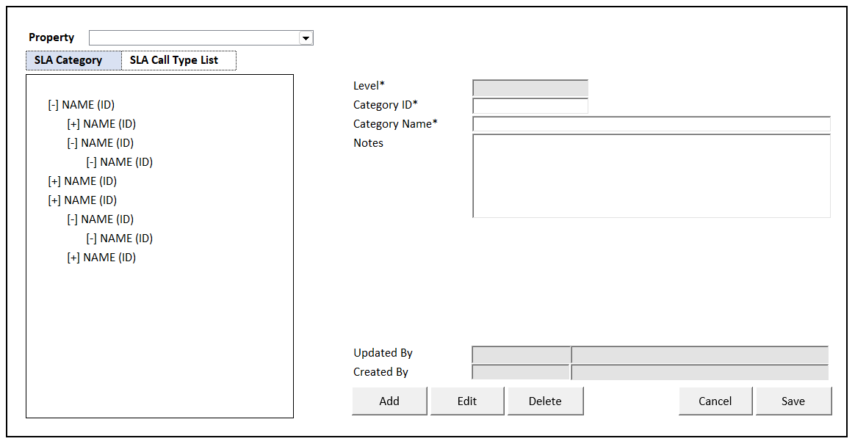

### TAB DEFINITION

|  |  |  |
| --- | --- | --- |
| **Tab Name** | **Action** | **Enabled** |
| SLA Category | Go to TAB SLA CATEGORY  Jalankan **Load SLA Category** | * + NOT on CRUD Mode |
| SLA Call Type List | Go to TAB SLA CALL TYPE LIST  Jalankan **Load SLA Call Type List** | * + NOT on CRUD Mode   + VAR_SELECTED_CATEGORY is not EMPTY |

### BUTTON DEFINITION

|  |  |  |
| --- | --- | --- |
| **Button Name** | **Action** | **Enabled** |
| Add | Jalankan ADD NEW PROCESS | * + NOT on CRUD Mode   + VAR_SELECTED_CATEGORY is not EMPTY |
| Edit | Jalankan EDIT PROCESS | * + NOT on CRUD Mode   + VAR_SELECTED_CATEGORY is not EMPTY   + VAR_SELECTED_LEVEL > 0 |
| Delete | Jalankan DELETE PROCESS | * + NOT on CRUD Mode   + VAR_SELECTED_CATEGORY is not EMPTY   + VAR_SELECTED_LEVEL > 0 |
| Cancel | Go to DISPLAY PROCESS | * + On CRUD Mode |
| Save | Jalankan SAVE & VALIDATION PROCESS | * + On CRUD Mode |

### ROLES

|  |  |
| --- | --- |
|  | **Test** |
| * User yg punya akses ke program |  |

### INITIAL PROCESS

|  |  |
| --- | --- |
|  | **Test** |
|  |  |

### DISPLAY PROCESS

#### FIELD DEFINITION

|  |  |  |  |
| --- | --- | --- | --- |
| **Name** | **Field** | **Type** | **Validation** |
| Property | CPROPERTY_ID | Combobox  Isi combobox dengan RSP_GS_GET_PROPERTY_LIST dengan parameter   * VAR_COMPANY_ID * VAR_USER_ID   Set ValueField = CPROPERTY_ID  Set TextField = CPROPERTY_NAME  Simpan hasil ke VAR_SELECTED_PROPERTY | On Value Changed,  IF Active Tab = ‘SLA Category’  **Load SLA Category**  Jalankan RSP_PM_GET_SLA_CATEGORY dengan parameter:   * + VAR_COMPANY_ID   + VAR_SELECTED_PROPERTY.CPROPERTY_ID |
| **SLA Category Tree View** |  |  |  |
| SLA Category | CCATEGORY_NAME (CCATEGORY_ID) | Tree View  **Load SLA Category**  Isi tree view dengan RSP_PM_GET_SLA_CATEGORY dengan parameter,   * + VAR_COMPANY_ID   + VAR_SELECTED_PROPERTY.CPROPERTY_ID   Simpan hasil ke VAR_SELECTED_CATEGORY dan VAR_SELECTED_LEVEL | On Value Changed   * + Reset Display Form |
| **Display Form** |  | **Data:** VAR_SELECTED_CATEGORY |  |
| Level | ILEVEL | Textbox, Disabled, Required |  |
| Category ID | CCATEGORY_ID | Textbox, Disabled, Required |  |
| Category Name | CCATEGORY_NAME | Textbox, Disabled, Required |  |
| Parent Category ID | CPARENT_CATEGORY_ID | Hidden |  |
| Notes | CNOTES | Textbox, Disabled |  |
| Updated By | CUPDATE_BY | Textbox, Disabled |  |
|  | DUPDATE_DATE | DateTimePicker, Disabled |  |
| Created By | CCREATE_BY | Textbox, Disabled |  |
|  | DCREATE_DATE | DateTimePicker, Disabled |  |

### ADD NEW PROCESS

#### ACTION

|  |
| --- |
|  |
| * Set **VAR_SAVE_MODE** = ‘ADD’ * Set Display Form value:   + Set **ILEVEL** = VAR_SELECTED_CATEGORY.ILEVEL + 1   + Set **CPARENT_CATEGORY_ID** = VAR_SELECTED_CATEGORY.CCATEGORY_ID * Enabled Fields: ‘Category ID’, ‘Category Name’, ‘Notes’ * Set focus to column: ‘Category ID’ |
| * Proses:   + ‘Save’ 🡪 Go To SAVE & VALIDATION PROCESS   + ‘Cancel’ 🡪 Go To DISPLAY PROCESS |

### EDIT PROCESS

#### ACTION

|  |
| --- |
|  |
| * Set **VAR_SAVE_MODE** = ‘EDIT’ * Set Display Form value: VAR_SELECTED_CATEGORY * Enabled Fields: ‘Category Name’, ‘Notes’ * Set focus to column: ‘Category Name’ |
| * Proses:   + ‘Save’ 🡪 Go To SAVE & VALIDATION PROCESS   + ‘Cancel’ 🡪 Go To DISPLAY PROCESS |

### DELETE PROCESS

#### ACTION

|  |
| --- |
|  |
| * Set **VAR_SAVE_MODE** = ‘DELETE’ |
| * **Delete SLA Process**   Jalankan RSP_PM_MAINTAIN_SLA_CATEGORY dengan parameter,  @CCOMPANY_ID = VAR_COMPANY_ID  @CPROPERTY_ID = VAR_SELECTED_PROPERTY.CPROPERTY_ID  @CCATEGORY_ID = ‘Category ID’  @CCATEGORY_NAME = ‘Category Name’  @CPARENT_CATEGORY_ID = ‘Parent Category ID’  @ILEVEL = ‘Level’  @CNOTES = ‘Notes’  @CACTION = ‘DELETE’  @CUSER_ID = VAR_USER_ID |

### SAVE & VALIDATION PROCESS

#### VALIDATION

|  |  |  |
| --- | --- | --- |
| **Field** | **Condition** | **Validation Message** |
| Category ID | Empty | Please fill Category ID! |
| Category Name | Empty | Please fill Category Name! |
|  |  |  |

#### ACTION

|  |
| --- |
|  |
| * **Validate** (See VALIDATION table)   IF Success, jalankan Save SLA CATEGORY  IF Failed, stay on Add/Edit Process   * **Save SLA Category**   Jalankan RSP_PM_MAINTAIN_SLA_CATEGORY dengan parameter,  @CCOMPANY_ID = VAR_COMPANY_ID  @CPROPERTY_ID = VAR_SELECTED_PROPERTY.CPROPERTY_ID  @CCATEGORY_ID = ‘Category ID’  @CCATEGORY_NAME = ‘Category Name’  @CPARENT_CATEGORY_ID = ‘Parent Category ID’  @ILEVEL = ‘Level’  @CNOTES = ‘Notes’  @CACTION = VAR_SAVE_MODE  @CUSER_ID = VAR_USER_ID |
| * Go to DISPLAY PROCESS |

## TAB SLA CALL TYPE LIST

### USER INTERFACE

#### INITIAL VERSION

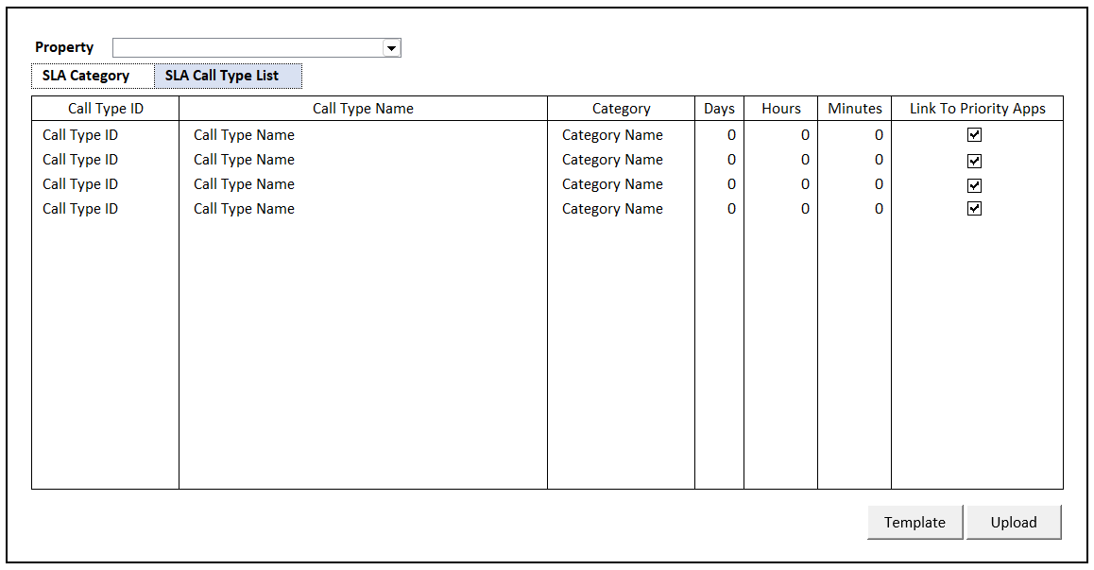

### BUTTON DEFINITION

|  |  |  |
| --- | --- | --- |
| **Button Name** | **Action** | **Enabled** |
| Template | Jalankan DOWNLOAD TEMPLATE PROCESS | * + NOT on CRUD Mode |
| Upload | Jalankan UPLOAD PROCESS | * + NOT on CRUD Mode |

### ROLES

|  |  |
| --- | --- |
|  | **Test** |
| * User yg punya akses ke program |  |

### INITIAL PROCESS

|  |  |
| --- | --- |
|  | **Test** |
| * **Load SLA Call Type List**   Jalankan RSP_PM_GET_SLA_CALL_TYPE_LIST dengan parameter, simpan hasil ke VAR_SLA_CALL_TYPE_LIST   * + VAR_COMPANY_ID   + VAR_SELECTED_PROPERTY.CPROPERTY_ID |  |

### DISPLAY PROCESS

#### FIELD DEFINITION

|  |  |  |  |
| --- | --- | --- | --- |
| **Name** | **Field** | **Type** | **Validation** |
| Property | CPROPERTY_ID | Combobox  Isi combobox dengan RSP_GS_GET_PROPERTY_LIST dengan parameter   * VAR_COMPANY_ID * VAR_USER_ID   Set ValueField = CPROPERTY_ID  Set TextField = CPROPERTY_NAME  Simpan hasil ke VAR_SELECTED_PROPERTY | On Value Changed,  IF Active Tab = ‘SLA Call Type List’  **Load SLA Call Type List**  Jalankan RSP_PM_GET_SLA_CALL_TYPE_LIST dengan parameter:   * + VAR_COMPANY_ID   + VAR_SELECTED_PROPERTY.CPROPERTY_ID |
| **SLA Call Type List Grid** |  | **Data:** VAR_SLA_CALL_TYPE_LIST | Allow:  ADD 🡪 Jalankan Add New Process  EDIT 🡪 Jalankan Edit Process  DELETE 🡪 Jalankan Delete Process |
| Call Type ID | CCALL_TYPE_ID | Textbox, Disabled, Required | Enabled: on ADD |
| Call Type Name | CCALL_TYPE_NAME | Textbox, Disabled, Required | Enabled: on ADD & EDIT |
| Category | CCATEGORY_NAME | Lookup, Disabled, Required | Enabled: on ADD & EDIT  Go to 🡪LOOKUP PROCESS  On value changed, update:  CCATEGORY_ID, CCATEGORY_NAME |
| Category ID | CCATEGORY_ID | Hidden |  |
| Days | IDAYS | NumericTextBox, Disabled | Enabled: on ADD & EDIT |
| Hours | IHOURS | NumericTextBox, Disabled | Enabled: on ADD & EDIT |
| Minutes | IMINUTES | NumericTextBox, Disabled | Enabled: on ADD & EDIT |
| Link To Priority Apps | LPRIORITY | Checkbox, Disabled | Enabled: on ADD & EDIT |

### ADD NEW PROCESS

#### ACTION

|  |
| --- |
|  |
| * Set **VAR_SAVE_MODE** = ‘ADD’ * Enabled Fields: ‘Call Type ID’, ‘Call Type Name’, ‘Category’, ‘Days, ‘Hours’, ‘Minutes’, ‘Link To Priority Apps’ * Set focus to column: ‘Call Type ID’ |
| * Proses:   + ‘Save’ 🡪 Go To SAVE & VALIDATION PROCESS   + ‘Cancel’ 🡪 Go To DISPLAY PROCESS |

### EDIT PROCESS

#### ACTION

|  |
| --- |
|  |
| * Set **VAR_SAVE_MODE** = ‘EDIT’ * Enabled Fields: ‘Call Type Name’, ‘Category’, ‘Days, ‘Hours’, ‘Minutes’, ‘Link To Priority Apps’ * Set focus to column: ‘Call Type Name’ |
| * Proses:   + ‘Save’ 🡪 Go To SAVE & VALIDATION PROCESS   + ‘Cancel’ 🡪 Go To DISPLAY PROCESS |

### DELETE PROCESS

#### ACTION

|  |
| --- |
|  |
| * Set **VAR_SAVE_MODE** = ‘DELETE’ |
| * **Delete Sla Call Type**   Jalankan RSP_PM_MAINTAIN_SLA_CALL_TYPE dengan parameter,  @CCOMPANY_ID = VAR_COMPANY_ID  @CPROPERTY_ID = VAR_SELECTED_PROPERTY.CPROPERTY_ID  @CCALL_TYPE_ID = ‘Call Type ID’  @CCALL_TYPE_NAME = ‘Call Type Name’  @CCATEGORY_ID = ‘Category ID’  @IDAYS = ‘Days’  @IHOURS = ‘Hours’  @IMINUTES = ‘Minutes’  @LPRIORITY = ‘Link To Priority Apps’  @CACTION = ‘DELETE’  @CUSER_ID = VAR_USER_ID |

### SAVE & VALIDATION PROCESS

#### VALIDATION

|  |  |  |
| --- | --- | --- |
| **Field** | **Condition** | **Validation Message** |
| Call Type ID | Empty | Please fill Call Type ID! |
| Call Type Name | Empty | Please fill Call Type Name! |
| Category | Empty | Please fill Category! |
| Days | Value < 0 | Negative days value is not allowed! |
| Hours | Value < 0 | Negative hours value is not allowed! |
| Minutes | Value < 0 | Negative minutes value is not allowed! |

#### ACTION

|  |
| --- |
|  |
| * **Validate** (See VALIDATION table)   IF Success, jalankan Save SLA Call Type  IF Failed, stay on Add/Edit Process   * **Save SLA Call Type**   Jalankan RSP_PM_MAINTAIN_SLA_CALL_TYPE dengan parameter,  @CCOMPANY_ID = VAR_COMPANY_ID  @CPROPERTY_ID = VAR_SELECTED_PROPERTY.CPROPERTY_ID  @CCALL_TYPE_ID = ‘Call Type ID’  @CCALL_TYPE_NAME = ‘Call Type Name’  @CCATEGORY_ID = ‘Category ID’  @IDAYS = ‘Days’  @IHOURS = ‘Hours’  @IMINUTES = ‘Minutes’  @LPRIORITY = ‘Link To Priority Apps’  @CACTION = VAR_SAVE_MODE  @CUSER_ID = VAR_USER_ID |
| * Go to DISPLAY PROCESS |

### DOWNLOAD TEMPLATE PROCESS

#### ACTION

|  |
| --- |
|  |
| * Download SLA Call Type List File from Server   Download Filename: ‘SLACallTypeListTemplate.xlsx   * Tampilkan file directory untuk proses **Save As Download** oleh user |
|  |

### UPLOAD PROCESS

#### USER INTERFACE

#### INITIAL VERSION

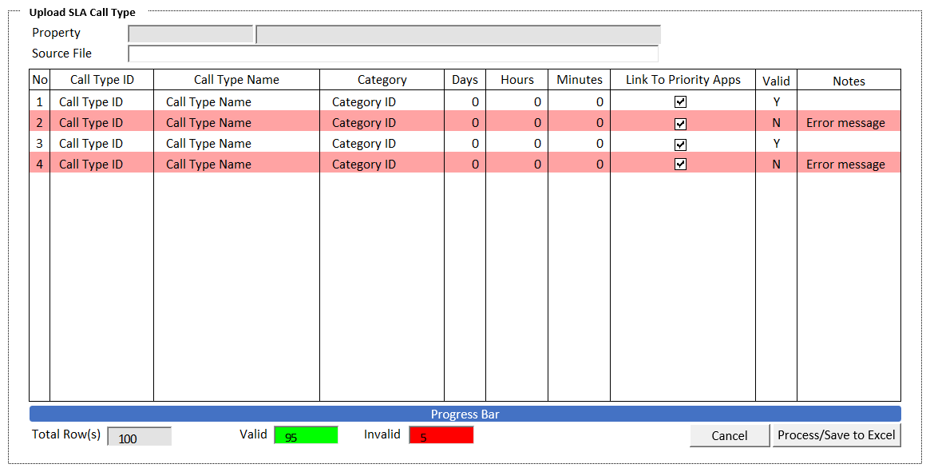

#### BUTTON DEFINITION

|  |  |  |
| --- | --- | --- |
| **Button Name** | **Action** | **Enabled** |
| Cancel | Jalankan CANCEL PROCESS |  |
| Process | Jalankan PROCESS | * + XLSX File Load Successfully   + VAR_TOTAL_ROWS > 0 |
| Save to Excel | Jalankan SAVE TO EXCEL PROCESS | * + Handled Error found in PROCESS |

#### INPUT PARAMETER

|  |  |
| --- | --- |
| **Parameter Name** | **Description** |
| PARAM_PROPERTY_ID | VAR_SELECTED_PROPERTY.CPROPERTY_ID from TAB SLA CALL TYPE LIST |
| PARAM_PROPERTY_NAME | VAR_SELECTED_PROPERTY.CPROPERTY_NAME from TAB SLA CALL TYPE LIST |
|  |  |

#### ROLES

|  |  |
| --- | --- |
|  | **Test** |
| * User yg punya akses ke program |  |

#### INITIAL PROCESS

|  |  |
| --- | --- |
|  | **Test** |
| * Load data from Input Parameter * Set **VAR_SOURCE_FILE** = ‘’ * Set **VAR_TOTAL_ROWS** = 0 * Set **VAR_VALID_ROWS** = 0 * Set **VAR_INVALID_ROWS** = 0 * Set Focus pada Source File Input |  |

#### DISPLAY PROCESS

#### FIELD DEFINITION

|  |  |  |  |
| --- | --- | --- | --- |
| **Name** | **Field** | **Type** | **Validation** |
| Property | PARAM_PROPERTY_ID | Textbox, Disabled |  |
|  | PARAM_PROPERTY_NAME | Textbox, Disabled |  |
| Source File | VAR_SOURCE_FILE | FileInput  Simpan data ke **VAR_UPLOAD_LIST, VAR_TOTAL_ROWS** | Accepts: .xlsx (Microsoft Excel)  Read Excel dari SheetName ‘SLACallType’  IF VAR_SOURCE_FILE is not Excel File   * Show message “File Type must Microsoft Excel .xlsx!”   IF VAR_SOURCE_FILE is empty   * Show message “File is empty!” |
| **SLA Call Type List Upload Grid** |  | **Data:** VAR_UPLOAD_LIST / VAR_RESULT | Allow: -  ReadOnly  If CVALID = ‘N’, RenderRow with background color ‘light red’ |
| No | INO | Textbox, Disabled |  |
| Call Type ID | CCALL_TYPE_ID | Textbox, Disabled, Required |  |
| Call Type Name | CCALL_TYPE_NAME | Textbox, Disabled, Required |  |
| Category | CCATEGORY_ID | Textbox, Disabled, Required |  |
| Days | IDAYS | NumericTextBox, Disabled |  |
| Hours | IHOURS | NumericTextBox, Disabled |  |
| Minutes | IMINUTES | NumericTextBox, Disabled |  |
| Link To Priority Apps | LPRIORITY | Checkbox, Disabled |  |
| Valid | CVALID | Textbox, Disabled |  |
| Notes | CNOTES | Textbox, Disabled |  |
| **Footer** |  |  |  |
| Total Rows | VAR_TOTAL_ROWS | Textbox, Disabled |  |
| Valid | VAR_VALID_ROWS | Textbox, Disabled  Background Color: Green | Update after PROCESS |
| Invalid | VAR_INVALID_ROWS | Textbox, Disabled  Background Color: Red | Update after PROCESS |

#### CANCEL PROCESS

##### ACTION

|  |
| --- |
|  |
| * Close this POPUP * Jalankan TAB SLA CALL TYPE’s DISPLAY PROCESS |
|  |

#### PROCESS

##### ACTION

|  |
| --- |
|  |
| * Set **Progess bar step** = 9 steps * Set **VAR_KEY_GUID** = New GUID * Set **VAR_ERROR_COUNT** = 0 * Reset Progress Bar |
| * Buat temporary table   CREATE TABLE #UPLOAD_SLA(  NO INT NOT NULL  , CCOMPANY_ID VARCHAR(8) NOT NULL  , CPROPERTY_ID VARCHAR(20) NOT NULL  , CCALL_TYPE_ID VARCHAR(20) NOT NULL  , CCALL_TYPE_NAME NVARCHAR(100) NOT NULL  , CCATEGORY_ID VARCHAR(20) NOT NULL  , IDAYS INT NOT NULL  , IHOURS INT NOT NULL  , IMINUTES INT NOT NULL  , LPRIOIRTY BIT NOT NULL  )   * Insert **VAR_UPLOAD_LIST** into #UPLOAD_SLA * Jalankan RSP_PM_UPLOAD_SLA_PROCESS dengan parameter, simpan hasil ke **VAR_RESULT**   @CCOMPANY_ID = VAR_COMPANY_ID  @CPROPERTY_ID = VAR_SELECTED_PROPERTY.CPROPERTY_ID  @CUSER_ID = VAR_USER_ID  @CKEY_GUID = VAR_KEY_GUID   * Set Upload Grid **DATA SOURCE** = **VAR_RESULT** |
| * Go To ‘DISPLAY PROCESS’ |

#### SAVE TO EXCEL PROCESS

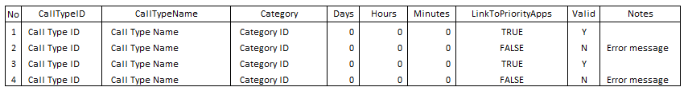

##### ACTION

|  |
| --- |
|  |
| * **Generate Template Process**   Buat template dengan detail sebagai berikut:  No  CallTypeID  CallTypeName  Category Days Hours Minutes LinkToPriorityApps  Valid Notes  Set Excel Sheet Name = ‘SLACallType’   * Create File Excel * Tampilkan file directory untuk proses **Save As Download** oleh user |
|  |

### LOOKUP PROCESS

#### USER INTERFACE

#### INITIAL VERSION

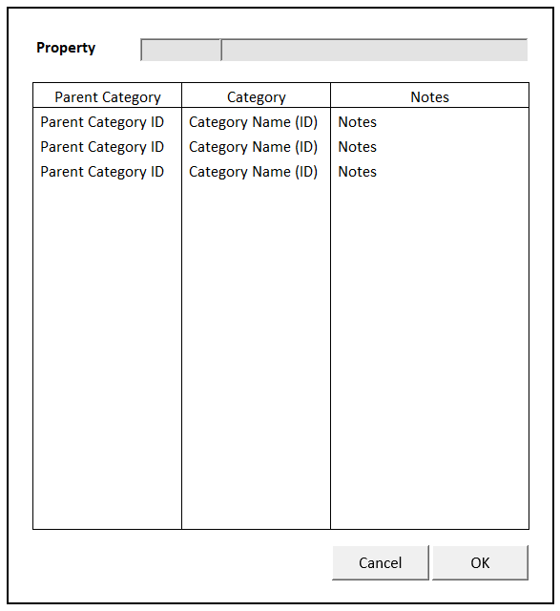

#### BUTTON DEFINITION

|  |  |  |
| --- | --- | --- |
| **Button Name** | **Action** | **Enabled** |
| Cancel | Jalankan CANCEL PROCESS |  |
| OK | Jalankan PROCESS |  |

#### INPUT PARAMETER

|  |  |
| --- | --- |
| **Parameter Name** | **Description** |
| PARAM_PROPERTY_ID | VAR_SELECTED_PROPERTY.CPROPERTY_ID from TAB SLA CALL TYPE LIST |
| PARAM_PROPERTY_NAME | VAR_SELECTED_PROPERTY.CPROPERTY_NAME from TAB SLA CALL TYPE LIST |
|  |  |

#### ROLES

|  |  |
| --- | --- |
|  | **Test** |
| * User yg punya akses ke program |  |

#### INITIAL PROCESS

|  |  |
| --- | --- |
|  | **Test** |
| * Load data from Input Parameter * Set **VAR_SELECTED_CATEGORY** NULL * **Load Assing SLA Category**   Jalankan RSP_PM_GET_ASSIGN_SLA_CATEGORY dengan parameter, simpan hasil ke VAR_ASSIGN_SLA_CATEGORY_LIST   * + VAR_COMPANY_ID   + VAR_SELECTED_PROPERTY.CPROPERTY_ID |  |

#### DISPLAY PROCESS

#### FIELD DEFINITION

|  |  |  |  |
| --- | --- | --- | --- |
| **Name** | **Field** | **Type** | **Validation** |
| Property | PARAM_PROPERTY_ID | Textbox, Disabled |  |
|  | PARAM_PROPERTY_NAME | Textbox, Disabled |  |
| **SLA Category Assign Grid** |  | **Data:** VAR_ASSIGN_SLA_CATEGORY_LIST  IF VAR_ASSIGN_SLA_CATEGORY_LIST is NULL   * Show message “Please Add SLA Category information first” | Allow: -  ReadOnly |
| Parent Category | CPARENT_CATEGORY_ID | Textbox, Disabled |  |
| Category | CCATEGORY_ID (CCATEGORY_NAME) | Textbox, Disabled |  |
| Notes | CNOTES | Textbox, Disabled |  |

#### CANCEL PROCESS

##### ACTION

|  |
| --- |
|  |
| * Close this POPUP * TAB SLA CALL TYPE’s GRID stay on CRUD MODE |
|  |

#### PROCESS

##### ACTION

|  |
| --- |
|  |
| * Close this POPUP * TAB SLA CALL TYPE’s GRID stay on CRUD MODE * Set TAB SLA CALL TYPE’s GRID   CCATEGORY_ID = VAR_SELECTED_CATEGORY.CCATEGORY_ID  CCATEGORY_NAME = VAR_SELECTED_CATEGORY.CCATEGORY_NAME |

# CR LIST

|  |  |  |
| --- | --- | --- |
| **CR** | **Description** | **Notes** |
|  |  |  |